ˆ _J Project Information DAAssignment- 1

**Team ID: LTVIP2025TMID48627**

**Team Size: 4**

**Team Leader: Y Mahaboob Basha**

**Team member: Shamshunnisa Makam**

**Team member: Teneti Saranya**

**Team member: T Sri Kanth**

**ID:** 22F21A3245

**INSTITUTION**: Gates Institute of Technology

**Project Title:** *Measuring the Pulse of Prosperity: An Index of Economic Freedom Analysis*

**Visualization Screenshots**

# Bar Chart – Total Sales by Product Line Caption:

This bar chart represents the total sales generated by each product line across all branches. It shows that *Food and Beverages*, *Electronic Accessories*, and *Fashion Accessories* are among the top contributors in revenue.

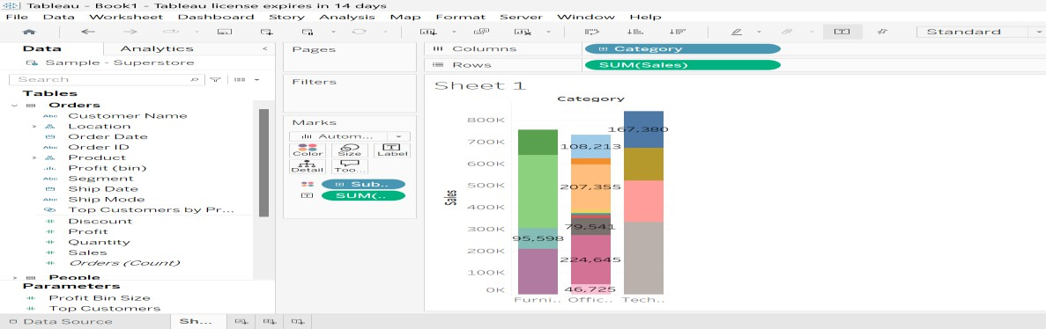

# Pie Chart – Payment Method Distribution Caption:

This pie chart displays the distribution of customer payment methods. The three payment methods include *Cash*, *Credit Card*, and *Ewallet*, with

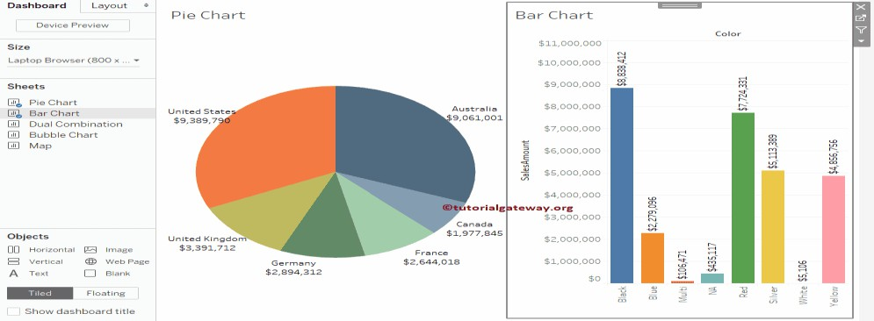

Cash being the most frequently used.

# Stacked Bar Chart – Gender-wise Sales across Branches Caption:

This stacked bar chart compares total sales from male and female customers in each branch (A, B, and C). The height of each bar shows total revenue, while the segments show gender contribution.

*Insight:* All branches maintain a balanced customer base across genders, with slight variances.

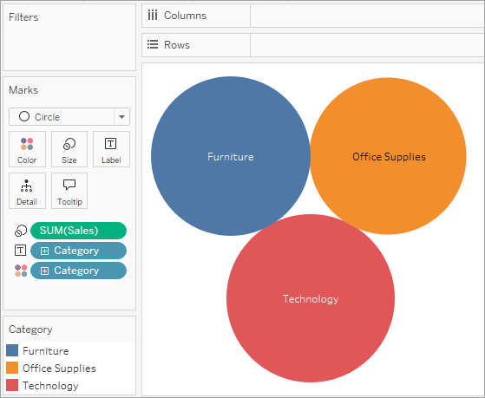

# Bubble Chart – Rating vs Gross Income Caption:

This bubble chart shows the relationship between customer rating and gross income. Bubble size represents total transaction value, and colors indicate customer types (Member vs Normal).

*Insight:* Higher-rated transactions are often associated with higher income and are largely from

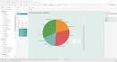

member customers.